Practical No. 06

Q.1] Write and Execute code to display selected hobbies using CheckBox.
Activity_main.xml:-
<?xml version="1.0" encoding="utf-8"?>
<LinearLayout
xmlns:android="http://schemas.android.com/apk/res/android"
android:id="@+id/main"
android:layout_width="match_parent"
android:layout_height="match_parent"
android:orientation="vertical"
android:gravity="center"
android:padding="20dp">
<TextView
android:layout_width="wrap_content"
android:layout_height="wrap_content"
android:text="Select Your Hobbies"
android:textSize="22sp"
android:textStyle="bold"
android:layout_marginBottom="10dp"/>
<CheckBox
android:id="@+id/cbReading"
android:text="Reading"
android:ems="10"
android:layout_width="wrap_content"
android:layout_height="wrap_content"/>
<CheckBox
android:id="@+id/cbDrawing"
android:text="Drawing"
android:ems="10"
android:layout_width="wrap_content"
android:layout_height="wrap_content"/>
<CheckBox
android:id="@+id/cbGaming"
android:text="Gaming"
android:ems="10"
android:layout_width="wrap_content"
android:layout_height="wrap_content"/>
<CheckBox
android:id="@+id/cbMusic"
android:text="Music"
android:ems="10"
android:layout_width="wrap_content"
android:layout_height="wrap_content"/>
<Button
android:id="@+id/btnShow"
android:text="Show Selected"
android:ems="10"
android:layout_margin="10dp"
android:layout_width="wrap_content"
android:layout_height="wrap_content"/>
<TextView
android:id="@+id/txtResult"
android:ems="10"
android:textSize="18sp"
android:text="Selected Hobbies"
android:layout_margin="10dp"
android:layout_width="wrap_content"
android:layout_height="wrap_content"/>
</LinearLayout>
MainActivity.java:
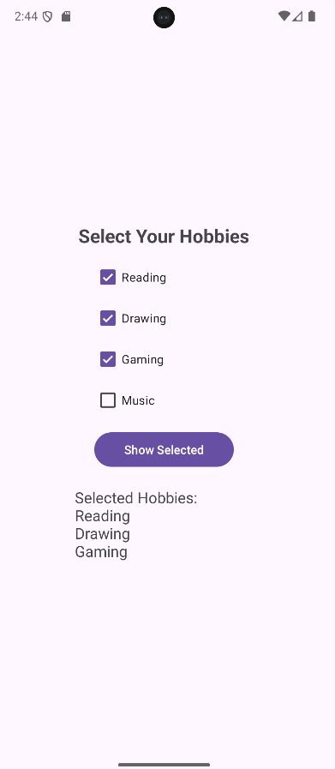
package com.techtitans.madpracticals;
import android.annotation.SuppressLint;
import android.os.Bundle;
import android.widget.Button;
import android.widget.CheckBox;
import android.widget.TextView;
import androidx.activity.EdgeToEdge;
import androidx.appcompat.app.AppCompatActivity;
import androidx.core.graphics.Insets;
import androidx.core.view.ViewCompat;
import androidx.core.view.WindowInsetsCompat;
public class MainActivity extends AppCompatActivity {
@Override
protected void onCreate(Bundle savedInstanceState) {
super.onCreate(savedInstanceState);
EdgeToEdge.enable(this);
setContentView(R.layout.activity_main);
CheckBox cbReading = findViewById(R.id.cbReading);
CheckBox cbDrawing = findViewById(R.id.cbDrawing);
CheckBox cbGaming = findViewById(R.id.cbGaming);
CheckBox cbMusic = findViewById(R.id.cbMusic);
Button btnShow = findViewById(R.id.btnShow);
TextView txtResult = findViewById(R.id.txtResult);
btnShow.setOnClickListener(v -> {
String result = "Selected Hobbies:";
if (cbReading.isChecked())
result += "\nReading";
if (cbDrawing.isChecked())
result += "\nDrawing";
if (cbGaming.isChecked())
result += "\nGaming";
if (cbMusic.isChecked())
result += "\nMusic";
txtResult.setText(result);
});
}
}
Q.2] Write and Execute code to count how many CheckBoxes are selected and display the count.
Activity_main.xml:-
<?xml version="1.0" encoding="utf-8"?>
<LinearLayout
xmlns:android="http://schemas.android.com/apk/res/android"
android:id="@+id/main"
android:layout_width="match_parent"
android:layout_height="match_parent"
android:orientation="vertical"
android:gravity="center"
android:padding="20dp">
<TextView
android:layout_width="wrap_content"
android:layout_height="wrap_content"
android:text="Select Your Hobbies"
android:textSize="22sp"
android:textStyle="bold"
android:layout_marginBottom="10dp"/>
<CheckBox
android:id="@+id/cbReading"
android:text="Reading"
android:ems="10"
android:layout_width="wrap_content"
android:layout_height="wrap_content"/>
<CheckBox
android:id="@+id/cbDrawing"
android:text="Drawing"
android:ems="10"
android:layout_width="wrap_content"
android:layout_height="wrap_content"/>
<CheckBox
android:id="@+id/cbGaming"
android:text="Gaming"
android:ems="10"
android:layout_width="wrap_content"
android:layout_height="wrap_content"/>
<CheckBox
android:id="@+id/cbMusic"
android:text="Music"
android:ems="10"
android:layout_width="wrap_content"
android:layout_height="wrap_content"/>
<Button
android:id="@+id/btnCount"
android:text="Count Selected"
android:ems="10"
android:layout_margin="10dp"
android:layout_width="wrap_content"
android:layout_height="wrap_content"/>
<TextView
android:id="@+id/txtCount"
android:text="Total Selected Hobbies : 0"
android:textSize="18sp"
android:layout_margin="10dp"
android:layout_width="wrap_content"
android:layout_height="wrap_content"/>
</LinearLayout>
MainActivity.java:
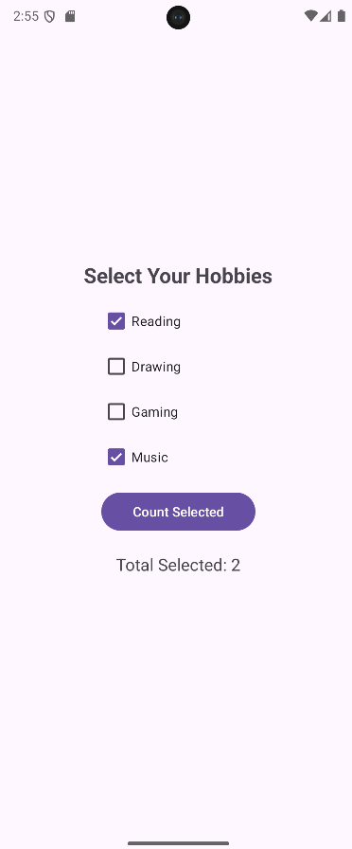
package com.techtitans.madpracticals;
import android.os.Bundle;
import android.view.View;
import android.widget.Button;
import android.widget.CheckBox;
import android.widget.TextView;
import androidx.activity.EdgeToEdge;
import androidx.appcompat.app.AppCompatActivity;
import androidx.core.graphics.Insets;
import androidx.core.view.ViewCompat;
import androidx.core.view.WindowInsetsCompat;
public class MainActivity extends AppCompatActivity {
@Override
protected void onCreate(Bundle savedInstanceState) {
super.onCreate(savedInstanceState);
EdgeToEdge.enable(this);
setContentView(R.layout.activity_main);
CheckBox cbReading = findViewById(R.id.cbReading);
CheckBox cbDrawing = findViewById(R.id.cbDrawing);
CheckBox cbGaming = findViewById(R.id.cbGaming);
CheckBox cbMusic = findViewById(R.id.cbMusic);
Button btnCount = findViewById(R.id.btnCount);
TextView txtCount = findViewById(R.id.txtCount);
btnCount.setOnClickListener(new View.OnClickListener() {
@Override
public void onClick(View v) {
int count = 0;
if (cbReading.isChecked()) {
count++;
}
if (cbDrawing.isChecked()) {
count++;
}
if (cbGaming.isChecked()) {
count++;
}
if (cbMusic.isChecked()) {
count++;
}
txtCount.setText("Total Selected: " + count);
}
});
}
}
Q.3] Write and Execute code to clear all CheckBox and RadioButton selections on button click.
Activity_main.xml:-
<?xml version="1.0" encoding="utf-8"?>
<LinearLayout
xmlns:android="http://schemas.android.com/apk/res/android"
android:id="@+id/main"
android:layout_width="match_parent"
android:layout_height="match_parent"
android:gravity="center"
android:orientation="vertical"
android:padding="20dp">
<TextView
android:layout_width="wrap_content"
android:layout_height="wrap_content"
android:text="Select Hobbies"
android:layout_marginStart="-40dp"
android:textStyle="bold"
android:textSize="20sp"
android:layout_marginBottom="8dp"/>
<CheckBox
android:id="@+id/cbReading"
android:text="Reading"
android:ems="10"
android:layout_width="wrap_content"
android:layout_height="wrap_content"/>
<CheckBox
android:id="@+id/cbDrawing"
android:text="Drawing"
android:ems="10"
android:layout_width="wrap_content"
android:layout_height="wrap_content"/>
<CheckBox
android:id="@+id/cbGaming"
android:text="Gaming"
android:ems="10"
android:layout_width="wrap_content"
android:layout_height="wrap_content"/>
<CheckBox
android:id="@+id/cbMusic"
android:text="Music"
android:ems="10"
android:layout_width="wrap_content"
android:layout_height="wrap_content"/>
<TextView
android:layout_width="wrap_content"
android:layout_height="wrap_content"
android:text="Select Gender"
android:textStyle="bold"
android:textSize="20sp"
android:layout_marginStart="-40dp"
android:layout_marginTop="12dp"
android:layout_marginBottom="6dp"/>
<RadioGroup
android:id="@+id/rgGender"
android:layout_width="wrap_content"
android:layout_height="wrap_content">
<RadioButton
android:id="@+id/rbMale"
android:text="Male"
android:ems="10"
android:layout_width="wrap_content"
android:layout_height="wrap_content"/>
<RadioButton
android:id="@+id/rbFemale"
android:text="Female"
android:layout_width="wrap_content"
android:layout_height="wrap_content"/>
<RadioButton
android:id="@+id/rbOther"
android:text="Other"
android:layout_width="wrap_content"
android:layout_height="wrap_content"/>
</RadioGroup>
<Button
android:id="@+id/btnClear"
android:text="Submit and Clear"
android:layout_marginTop="15dp"
android:layout_width="wrap_content"
android:layout_height="wrap_content"/>
</LinearLayout>
MainActivity.java:
package com.techtitans.madpracticals;
import android.os.Bundle;
import android.view.View;
import android.widget.Button;
import android.widget.CheckBox;
import android.widget.RadioButton;
import android.widget.Toast;
import androidx.activity.EdgeToEdge;
import androidx.appcompat.app.AppCompatActivity;
import androidx.core.graphics.Insets;
import androidx.core.view.ViewCompat;
import androidx.core.view.WindowInsetsCompat;
public class MainActivity extends AppCompatActivity {
@Override
protected void onCreate(Bundle savedInstanceState) {
super.onCreate(savedInstanceState);
EdgeToEdge.enable(this);
setContentView(R.layout.activity_main);
CheckBox cbReading = findViewById(R.id.cbReading);
CheckBox cbDrawing = findViewById(R.id.cbDrawing);
CheckBox cbGaming = findViewById(R.id.cbGaming);
CheckBox cbMusic = findViewById(R.id.cbMusic);
RadioButton rbMale = findViewById(R.id.rbMale);
RadioButton rbFemale = findViewById(R.id.rbFemale);
RadioButton rbOther = findViewById(R.id.rbOther);
Button btnClear = findViewById(R.id.btnClear);
// FIX 2: Cleaned up the braces for the OnClickListener
btnClear.setOnClickListener(new View.OnClickListener() {
@Override
public void onClick(View v) {
int count = 0;
String gender = "Not Selected";
if (cbReading.isChecked()) {
count++;
cbReading.setChecked(false);
}
if (cbDrawing.isChecked()) {
count++;
cbDrawing.setChecked(false);
}
if (cbGaming.isChecked()) {
count++;
cbGaming.setChecked(false);
}
if (cbMusic.isChecked()) {
count++;
cbMusic.setChecked(false);
}
if (rbMale.isChecked()) {
gender = "Male";
rbMale.setChecked(false);
}
if (rbFemale.isChecked()) {
gender = "Female";
rbFemale.setChecked(false);
}
if (rbOther.isChecked()) {
gender = "Other";
rbOther.setChecked(false);
}
Toast.makeText(MainActivity.this,"Selected Hobbies: " + count + "\nGender: " + gender, Toast.LENGTH_LONG).show();
}
});
}
}
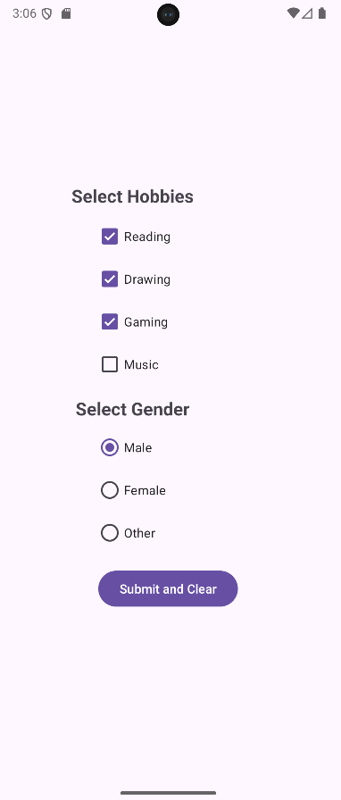
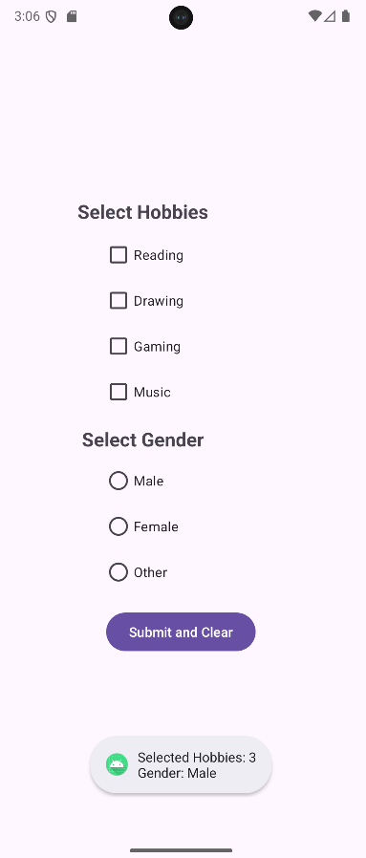

Q.4] Write code to change the text color of a RadioButton when selected.
Activity_main.xml:-
<?xml version="1.0" encoding="utf-8"?>
<LinearLayout
xmlns:android="http://schemas.android.com/apk/res/android"
android:id="@+id/main"
android:layout_width="match_parent"
android:layout_height="match_parent"
android:orientation="vertical"
android:gravity="center"
android:padding="20dp">
<TextView
android:layout_width="wrap_content"
android:layout_height="wrap_content"
android:text="Select Option"
android:textSize="20sp"
android:textStyle="bold"
android:layout_marginBottom="10dp"/>
<RadioGroup
android:id="@+id/rgOptions"
android:layout_width="wrap_content"
android:layout_height="wrap_content">
<RadioButton
android:id="@+id/rbOption1"
android:text="Option 1"
android:layout_width="wrap_content"
android:layout_height="wrap_content"/>
<RadioButton
android:id="@+id/rbOption2"
android:text="Option 2"
android:layout_width="wrap_content"
android:layout_height="wrap_content"/>
<RadioButton
android:id="@+id/rbOption3"
android:text="Option 3"
android:layout_width="wrap_content"
android:layout_height="wrap_content"/>
</RadioGroup>
</LinearLayout>

MainActivity.java:
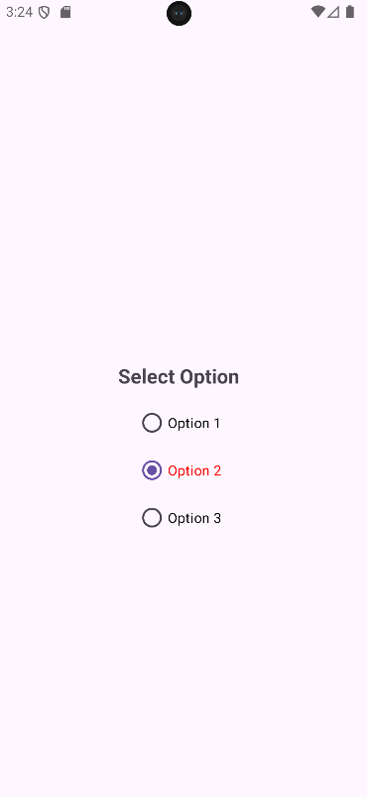
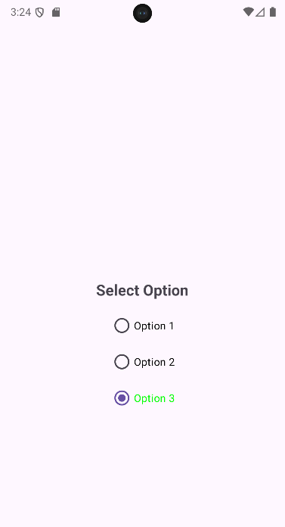
package com.techtitans.madpracticals;
import android.graphics.Color;
import android.os.Bundle;
import android.widget.RadioButton;
import android.widget.RadioGroup;
import androidx.activity.EdgeToEdge;
import androidx.appcompat.app.AppCompatActivity;
import androidx.core.graphics.Insets;
import androidx.core.view.ViewCompat;
import androidx.core.view.WindowInsetsCompat;
public class MainActivity extends AppCompatActivity {
@Override
protected void onCreate(Bundle savedInstanceState) {
super.onCreate(savedInstanceState);
EdgeToEdge.enable(this);
setContentView(R.layout.activity_main);
ViewCompat.setOnApplyWindowInsetsListener(findViewById(R.id.main),
(v, insets) -> {
Insets systemBars = insets.getInsets(WindowInsetsCompat.Type.systemBars());
v.setPadding(systemBars.left, systemBars.top,
systemBars.right, systemBars.bottom);
return insets;
});
RadioGroup rgOptions = findViewById(R.id.rgOptions);
RadioButton rb1 = findViewById(R.id.rbOption1);
RadioButton rb2 = findViewById(R.id.rbOption2);
RadioButton rb3 = findViewById(R.id.rbOption3);
rgOptions.setOnCheckedChangeListener(new RadioGroup.OnCheckedChangeListener() {
@Override
public void onCheckedChanged(RadioGroup group, int checkedId) {
// reset all colors
rb1.setTextColor(Color.BLACK);
rb2.setTextColor(Color.BLACK);
rb3.setTextColor(Color.BLACK);
if (checkedId == R.id.rbOption1) {
rb1.setTextColor(Color.BLUE);
}
if (checkedId == R.id.rbOption2) {
rb2.setTextColor(Color.RED);
}
if (checkedId == R.id.rbOption3) {
rb3.setTextColor(Color.GREEN);
}
}
});
}
}

